**Objectives**

* Demonstrate using third party date picker in web page
  + gijgo, getting started, setting date format
* Demonstrate displaying form elements with RWD
  + Develop form with textbox, password, drop down, date using gijgo, radio button and checkbox form-row, form-group, form-control, form-check, form-check-input, form-check-label, form-check-input
* Demonstrate customizing bootstrap styles
  + Separate CSS file for customization, overriding the styles of Bootstrap

**Using Third Party Library for Date**  
  
Create a text field for capturing date using a third party JavaScript library called Gijgo.

Default display of the date field.   
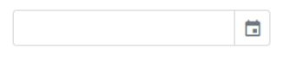  
Clicking on the icon or having the focus within the textbox should have a layout like this.   
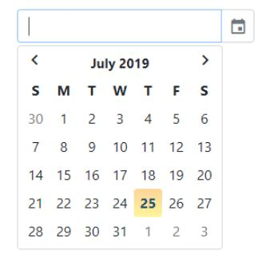

Use gijgo third party library to include calendar. Refer instructions below.

1. Include the below CSS in header:

<link href="https://unpkg.com/gijgo@1.9.13/css/gijgo.min.css" rel="stylesheet" type="text/css"/>

1. Include the below script after the body tag in html:

<script src="https://unpkg.com/gijgo@1.9.13/js/gijgo.min.js" type="text/javascript"></script>

<script>

$('#dateOfBirth').datepicker({

uiLibrary: 'bootstrap4',

format: 'dd/mm/yyyy'

});

</script>

1. Include the following code within body:

<div class="container">

<div class="row">

<div class="col-lg-3">

<input type="text" class="form-control" id="dateOfBirth">

</div>

</div>

</div>

Design form to edit employee details

To capture employee details create a form similar to the one defined below.   
  
**Desktop**  
  
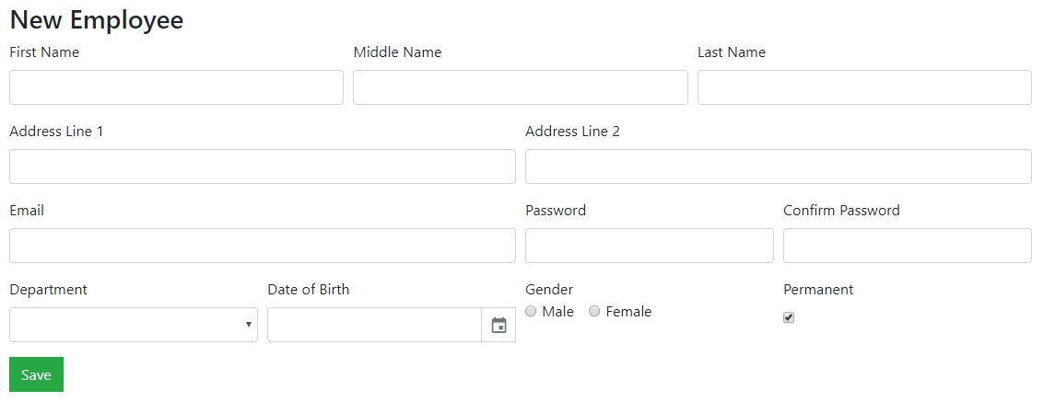

**Mobile**  
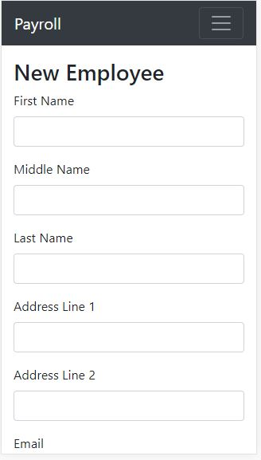  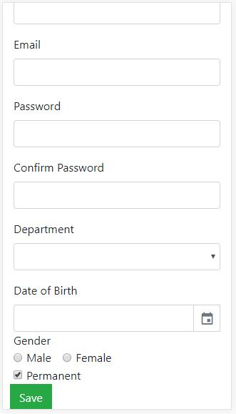  
  
**NOTE:** Apply email validation using HTML5.

**Customize Bootstrap Styles**   
  
For a new application to be developed the default primary buttons is expected to be in green color with sharp edges (refer layout below). Achieve this by defining a new CSS file overriding the .btn and .btn-primary styles.   
  
Before Change  
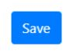  
After Change   
  
